Ocean Reef Senior High School

Year 11 ATAR Psychology (Unit 11_AEPSY)

Assessment Task 7 – Test 3

53 marks (5% Response)

**MARKING KEY**

**OUTCOMES:**

|  |  |
| --- | --- |
| *Outcome 1:* | *Psychological understandings* |
| *Outcome 3:* | *Applying and relating psychological understandings* |
| *Outcome 4:* | *Communication in psychology* |

**ALLOCATED TIME FOR THE TASK:**

* *You have one period to complete the test in class*.

**INSTRUCTIONS:**

* *Attempt all questions*
* *No notes, files etc. to be accessed during the test*

|  |  |
| --- | --- |
| **Section One – Multiple Choice** | |
| **Total** | **/ 20** |

|  |  |
| --- | --- |
| **Section Two – Short Answer** | |
| Question 1 – Developmental Psychology | / 10 |
| Question 2 – Psychology of Personality | / 23 |
| **Total** | **/ 33** |

|  |  |
| --- | --- |
| **Total Marks** | |
| Section 1 | / 20 |
| Section 2 | / 33 |
| **Assessment Task 7 – Total Marks** | **/ 53** |

Section One – Multiple Choice

20 questions (20 marks)

1. During motor development children:
   1. walk before they crawl
   2. **sit before they stand**
   3. crawl before they sit
   4. stand and walk at the same time
2. Coaching children’s sport requires that:
   1. children already know how to play
   2. children belong to a team
   3. children have natural ability
   4. **there is an opportunity for children to develop their skills**
3. A child who is egocentric and cannot conserve is most likely in which of Piaget’s four stages of development:
   1. formal operational
   2. **pre-operational**
   3. concrete operational
   4. sensori-motor
4. *Intelligence quotient* is:
   1. a measure of social and emotional intelligence
   2. generally measured on a scale with a mean of 110 and standard deviation of 15
   3. a score on a test of intelligence, in comparison with other people of the same background
   4. **a standard measure that compares a person’s mental age with their chronological age**
5. Psychologists use twin studies when examining the development of intelligence as twins allow psychologists to determine the influence of _____________ in the development of their intelligence:
6. genetics
7. **environment**
8. both genetics and environment
9. Identical twins reared apart showed:
   1. less similarity in IQ scores than fraternal twins raised together
   2. **more similarity in IQ scores than fraternal twins raised together**
   3. more similarity than identical twins raised together
   4. less similarity in IQ than fraternal twins reared apart
10. Australian Aborigines perform less well on intelligence tests because
    1. they are culturally isolated
    2. **the tests do not reflect their cultural experiences**
    3. they are unable to show logical thinking
    4. they do not benefit from formal education
11. Kearins (1986) concluded that the superior _______ skills of Aboriginal children are part of a set of wider, intellectual skills that are maintained by the culture.
12. **visual-spatial**
13. verbal
14. logic
15. critical-thinking
16. The first emotion recognised by infants is:
    1. joy
    2. sadness
    3. fear
    4. **all of the above**
17. The motor skill of skipping is achieved by most children during which age category?
    1. 0 – 2
    2. **2 – 6**
    3. 6 – 10
    4. 11 – 12
18. The role of unconscious processes in the development of personality is central to __________ theory of personality:
    1. Rogers’
    2. Maslow’s
    3. McCrae & Costa’s
    4. **Freud’s**
    5. Eysenck’s
19. The Oedipus and Electra complex occur during what psycho-sexual stage, as theorised by Freud?
    1. oral
    2. anal
    3. **phallic**
    4. latent
    5. genital
20. Trait theories of personality focus on:
    1. group differences
    2. **individual differences**
    3. models of personality development
    4. unconscious processes
21. If a person is neurotic, they are least likely to display which one of the following behaviours:
22. restlessness
23. **talkative**
24. anxious
25. aggressive
26. Tom is described as being ‘honest’. According to Allport this would be an example of a _________ trait.
    1. common
    2. cardinal
    3. **central**
    4. secondary
27. Personality psychologists who follow psychodynamic theories, such as that of Freud, are likely to use:
    1. self-report inventories
    2. pen and pencil tests
    3. **projective tests**
    4. intelligence tests
28. According to Allport, secondary personality traits are usually only known by our family and close friends.
    1. **true**
    2. false
29. Which of the following is NOT a limitation of using self-report methods to measure personality:
    1. results are open to interpretation by the interviewer
    2. relies on honesty by the respondent
    3. **results can generate quantitative data**
    4. relies on the questions being asked as being valid measures of the personality
30. A limitation of using the *case study* method to study personality is:
    1. the results cannot be generalised to the wider population
    2. the researchers own subjective feeling may influence the case study
    3. the results are difficult to replicate
    4. **all of the above**
31. Which of the following does NOT describe a trait?
    1. has a genetic basis
    2. **describes similarities between people’s personalities**
    3. predicts behaviour
    4. describes cognitive, emotional and behavioural tendencies

Section Two - Short answer questions

Two questions = 33 marks

**Question One – Developmental Psychology (10 marks)**

1. Define the term *intelligence*. (*2 marks*)

* *2 marks = correct answer*
* *1 mark = mostly correct answer*

*Either one of the following two definitions:*

*Intelligence is what enables us to learn, to adapt to things around us, to perform actions well, to solve problems and to think abstractly*

*Intelligence is the global or aggregate capacity to act purposefully, think rationally and deal effectively with the environment (Wechsler)*

1. Describe what psychologists mean by:

* *Nature*: *genetics from parents, fixed at conception (1 mark)*
* *Nurture: all environmental influences after conception (1 mark)*

1. “*Differences in IQ support the role of ‘nature’ over ‘nurture.*’”

Evaluate the accuracy of this statement in the space below. Refer to *relevant psychological research* in your answer. (*6 marks*)

* *1 mark = stating the statement is correct/incorrect (answer will depend on the evidence provided by student)*
* *1 mark = stating that both nature and nurture plays roles in intelligence, and hence differences in intelligence*
* *4 marks = references to relevant psychological evidence. Student may discuss one study only (must be outstanding analysis for the full 4 marks) or refer to two separate studies (for 2 marks each).*
* *Examples to refer to could include:*
  + *Judith Kearins: research with Indigenous Australians. Found they have higher levels of visual-spatial intelligence. Found this to be due to living in the harsh Australian climate where strong spatial awareness is critical to survival. This is a nurture (environment) component*
  + *Bouchard: studied identical twins who had been reared apart. Found that:*
    - *IQ’s were not as similar as identical twins reared together (role of environment)*
    - *IQ more similar than for fraternal twins reared together (role of genetics)*

*This demonstrates both a nature and nurture component.* ***However, it does indicate nature potentially plays more of a role****.*

**Question Two – Psychology of Personality (23 marks)**

1. Define the term *personality*. (*2 marks*)

* 2 marks = correct answer
* 1 mark = mostly correct answer

*Personality is the characteristic ways of thinking, feeling and behaving that make a person unique*

1. Describe each of the following parts of Freud’s theory of personality: (*12 marks*)

* *1 mark for each correct point*
* *2 marks maximum for each section*
* *Students can include any combination of the points below for one mark each*

|  |  |
| --- | --- |
| *Name* | *Description* |
| Id | * *Primitive part of our personality* * *Operates on the pleasure principle* * *Made up of biological urges for food, shelter and sexual gratification* * *It is irrational and impulsive* * *Is the unconscious part of our being* |
| Ego | * *Is the regulator of behaviour* * *Sets the standards for our behaviour* * *Operates on the reality principle: will look to maximise pleasure but only if it can get away with it* * *Is in conscious control of our behaviour* * *Plays the mediator between the id and the superego* |
| Superego | * *Is the voice of conscience* * *Focuses on how we ought to behave* * *Is the perfectionist part of us* * *Leads to feelings of guilt, shame and pride* |
| Conscious | * *Refers to everything we are aware of* * *Includes stimuli from the environment, physical sensations and our thoughts and feelings* |
| Pre-conscious | * *Refers to memories just below the level of conscious awareness* * *Can be retrieved if thought about* |
| Unconscious | * *Contains thoughts and memories that are deeply hidden but which cause desires we cannot control* * *Includes things that have been repressed* * *Is where the id is* |

1. In the diagram below name in order the five stages of Maslow’s hierarchy of needs. (*5 marks*)

* *1 mark for each correctly identified stage*
* *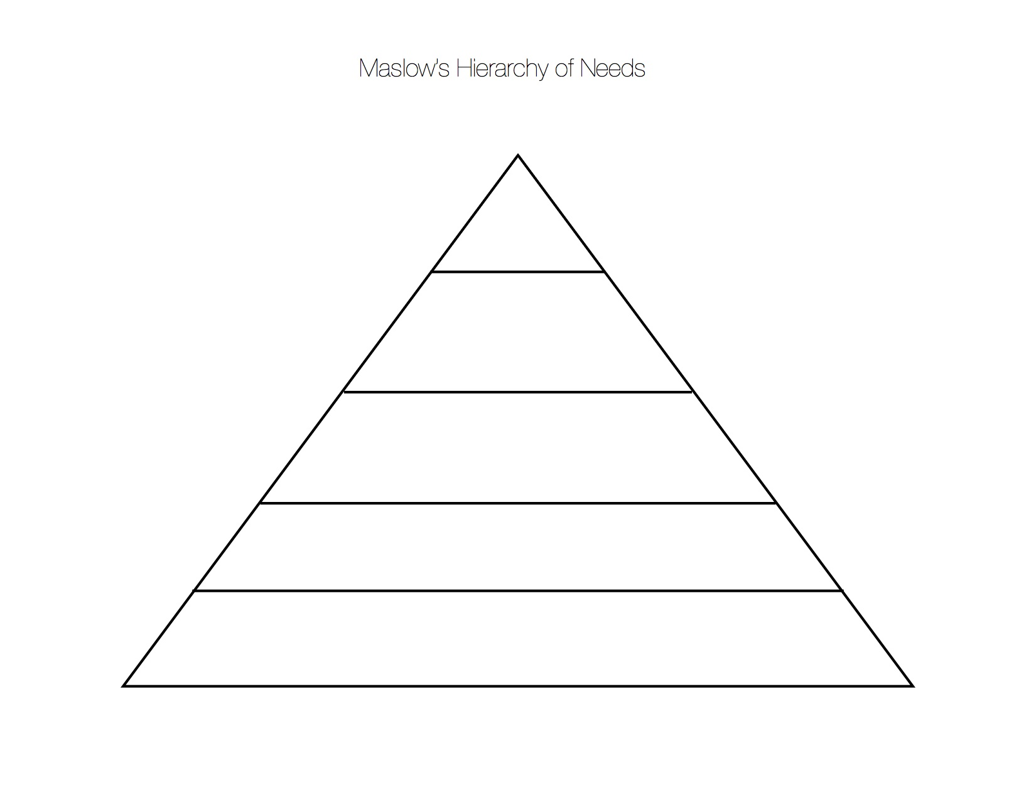From top:*
  + *Self-actualised*
  + *Esteem needs*
  + *Love and belongingness needs*
  + *Safety needs*
  + *Physiological needs*

1. *Sonya is a 20 year old woman. Her hobbies are reading and watching movies. Sonya would prefer to go out for dinner with her friends than to a big party. For as long as she can remember, Sonya has wanted to be a psychologist and to help people with disabilities. Sonya is studying psychology at university. She works very hard at her studies and, although she always tries to do her best, she never gets stressed out by exams. Instead, she believes in her preparation and ability to get her through. Sonya’s close friends describe her as ‘level-headed’; a person who is able to stay calm in unsettling situations and who can think clearly when the pressure is on. Sonya has a very close, loving relationship with her parents and younger brother. If given the option, Sonya would prefer to spend time with her family and close friends, as opposed to with her wider circle of friends and acquaintances. Although Sonya has a Facebook account, she mainly uses it to see what her friends are doing as opposed to posting information about herself.*

Using Eysenck’s theory of personality, identify and describe **two (2)** traits Sonya is *high in*. Include evidence from the description above to support your answer. (*4 marks*)

Trait 1:

* *1 mark = stating high in* ***introversion***
* *1 mark for any of the following points*:
  + *hobbies are reading and watching movies.*
  + *prefer to go out for dinner with her friends than to a big party.*
  + *would prefer to spend time with her family and close friends, as opposed to with her wider circle of friends and acquaintances.*
  + *although Sonya has a Facebook account, she mainly uses it to see what her friends are doing as opposed to posting information about herself.*

Trait 2:

* *1 mark = stating high in* ***emotional stability***
* *1 mark for any of the following points:*
  + *she never gets stressed out by exams. Instead, she believes in her preparation and ability to get her through.*
  + *close friends describe her as ‘level-headed’; a person who is able to stay calm in unsettling situations and who can think clearly when the pressure is on.*

Psychology Multiple Choice Answer Sheet

Name: _________________________

|  |  |
| --- | --- |
| Question | Answer |
| 1 | B |
| 2 | D |
| 3 | B |
| 4 | D |
| 5 | B |
| 6 | B |
| 7 | B |
| 8 | A |
| 9 | D |
| 10 | B |
| 11 | D |
| 12 | C |
| 13 | B |
| 14 | B |
| 15 | C |
| 16 | C |
| 17 | A |
| 18 | C |
| 19 | D |
| 20 | B |

Total / 20: ____________